Zach Sherman

Portfolio Writeup – SI 339

* Precise Breakdown of Expected Score:
* Header Tag – 10/10
* Footer Tag – 8/10
* Nav Tag- 10/10
* Current Page- 15/15
* Validates- 20/20:
  + Index page - 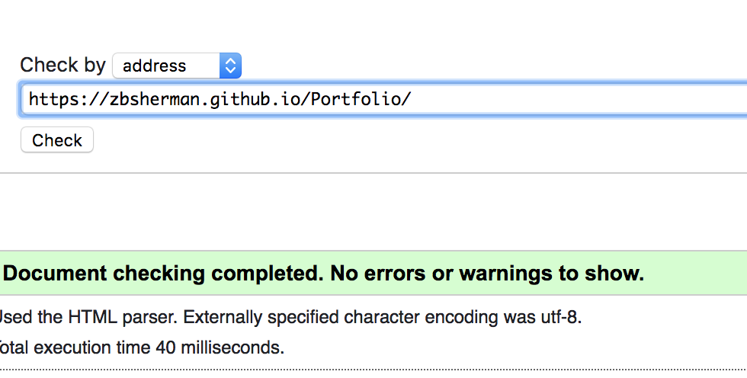
  + About page - 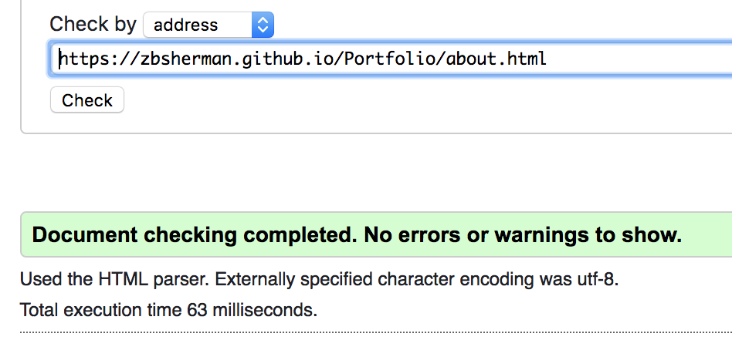
  + Contact page- 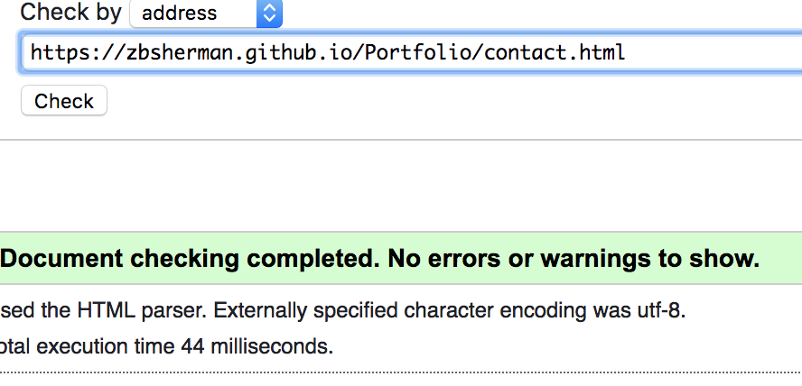
  + Extra page- 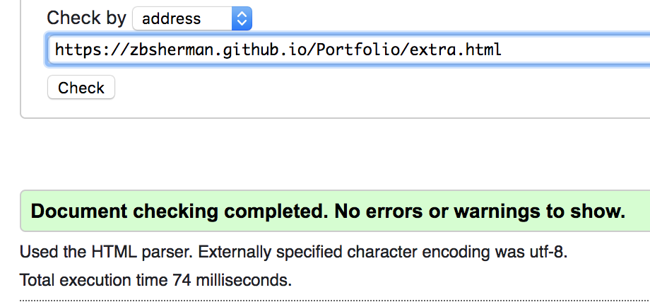
* Page with at least Seven Images – 15/15
  + Extra page has 7 images that are in a grid display and changes with screen size
* Responsive Design- 20/20
  + Nav changes at 3 different screen sizes, other specific content layout changes in about page, contact page, and extra page when size changes
* Self styled CSS classes- 15/15
  + I have way more than 3 classes that are styled excellently.
* Media Query- 10/10
  + I have 5 media queries, 4 of which have at least 3 rules
* Header and footer on all four pages- 10/10
* Demo- 5/5
  + Monday @ 2:55pm
* A level, Above and beyond – 20/30, 10/10
  + I have mastered the grid display, which can be seen in my Extras page and my contact page. I really enjoy playing around with the different grids and sketching them out before putting the content into the webpages, which I did for this. I also have added a script to make the banner on my home page switch between images automatically. The thing I feel that I mastered the most and enjoyed doing the most is writing media queries. By trying to create the most responsive design possible, I was able to set my content out as precisely as I wanted it for each size of screen. It was interesting to see the difference that screen sizes made on my display and troubleshooting it via media queries allowed me to get closer to my content and design.

Expected Score Total: 168/180 – 93.3%